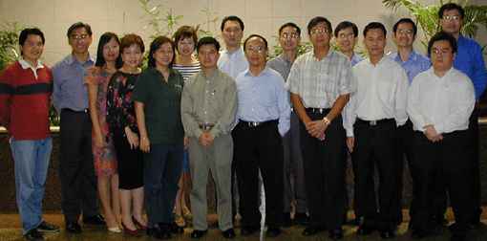

EXECUTIVE COMMITTEE FOR 2003/2004

President Yap Swee Hoo UOB Kay Hian Pte Lt
Vice-President Albert Fong OCBC Securities Pte Ltd
Hon. Secretary John Wee OCBC Securities Pte Ltd
Asst. Hon. Secretary Heng Liang OCBC Securities Pte Ltd
Hon. Treasurer Clement Wong UOB Kay Hian Pte Ltd
Asst. Hon. Treasurer Ronald Loo OCBC Securities Pte Ltd
Publications Secretary Nancy Lim UOB Kay Hian Pte Ltd
Asst. Pub. Secretary Ng Chee Seng DBS Vickers Secu Pte Ltd

Committee Members
Benjamin Sim Lim & Tan Securities Pte
Jimmy Ho UOB Kay Hian Pte Ltd
Sophie Chung UOB Kay Hian Pte Ltd
Jennifer Lim UOB Kay Hian Pte Ltd
Constance Tan UOB Kay Hian Pte Ltd
William Tan UOB Kay Hian Pte Ltd
Sumardi Lee UOB Kay Hian Pte Ltd
Steven Ong UOB Kay Hian Pte Ltd
Hon. Auditors
Ivy Tan UOB Kay Hian Pte Ltd
Eric Chan Kim Eng Ong Asia Securities
Pte Ltd

AGM Cum Dinner

The Committee was encouraged by the 200-odd members who attended the AGM cum
Dinner held at the Noble House,UIC Building on 25th March 2003.

The AGM began with the President, Mr Yap Swee Hoo,giving a welcome speech to the members of the society.

Mr Yap recounted how liberalization of the Singapore securities market and the current war in Iraq created difficulties for both trading representatives and member companies. However, remisiers are a sturdy and hardy people and will always strive to work for the best of their profession and community.

Mr Yap also informed members that the Co-op appears to be in the final stage of approval. The proposed constitution and business plan had been submitted to the
Registrar of Co-operative who had reverted with a few amendments. The business plan submitted included establishing a school of education and engaging in activities covering travel & leisure, health information, food & beverages and property.

The President concluded with the vision of the Co-op and the Society of Remisiers showing exponential growth in the years ahead.

************************************************

The AGM ended with the election of the new Executive Committee, after which a sumptious Chinese dinner was served. Many members, thereafter, complimented the choice of venue, as well as the items chosen from the menu.

For entertainment and fun, we had our very own in-house representative, Mr Thng Beng Hooi, who set a most enjoyable trivia, testing our knowledge. Not forgetting the Karaoke session, set-up for members to participate...And participate, they did!! There was good clean fun and laughter and applause as some of the remisers took to the stage showing off their singing talents. Indeed it was very entertaining and highly enjoyed by all.

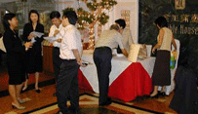
Finally, 28 persons went home with lucky draw prizes, due to the generosity of SRS and her patron, Mr Lee Wee Seng, who donated the top 5 prizes. It rounded up a great evening for all who attend
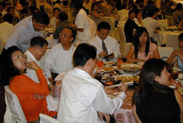
Kudos goes to the Organizing Committee who worked so hard for this event.

